**QUADRATIC TRANSFORMATIONS**

**(x, y) = (h, k)**

**Standard form: y = ax2 + bx+c**

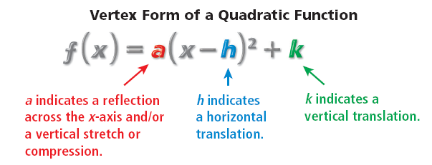

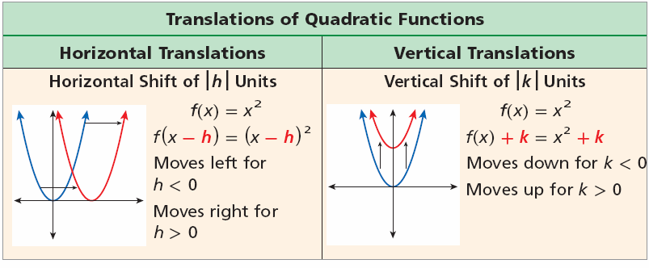

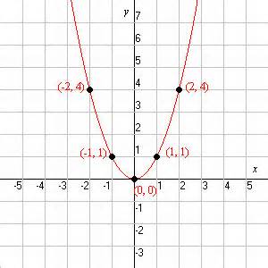**PARENT GRAPH, y=x2**

**1. If 0 < a < 1: Parabola Compresses Vertically**

**2. If a > 1: Parabola Stretches Vertically**

**3. If a < 1 (Neg. a): Parabola reflects across X axis**

***REMEMBER:* If quadratic is in standard form**

$y=ax^{2}+bx+c$**, you find the vertex $\frac{-b}{2a}$.**

**If quadratic is in vertex form, $y={a\left(x-h\right)}^{2}+k$**

**you need to find (h, k).**

**\*Remember, h comes out opposite from equation**

**To plot additional points: a(1,3) method**